***Localr***

**Business Requirements Document**

**Version 2.0**

**Topikós**

**Original Submission: 2/12/20**

**Updated Submission: 3/09/20**

**TABLE OF CONTENTS**

1. **PREFACE** **3**
2. **STRATEGY** **4**
3. **SWOT** **5**
4. **MARKET SEGMENTS** **6**
5. **PRIMARY MARKET RESEARCH** **7**
6. **SECONDARY MARKET RESEARCH** **12**
7. **APPENDIX : USER PROFILES 15**

## PREFACE

In the past few years, the accessibility and availability of news has increased for users due to the advancement of the internet and smartphones. However, as the world gets more interconnected due to the wide reach of the internet, the localization of news has decreased and the accuracy of the reporting has also been affected. This user preference has affected news-reporting and has influenced the emergence of the "fake news" phenomenon. Problems such as "fake news" and inaccurate news-reporting bombard users with irrelevant and uninteresting news. Furthermore, users have started to rely on social media for their news due to the ease and speed of delivery, however, the reliability of news from social media tends to be inaccurate because social media's purpose was not meant to be a news-reporting network. The purpose of the Localr app is to introduce local city news to users in a fast, easy-to-understand way. The cross-platform app will utilize a no-nonsense map interface that will pin news based on news article locations. Users can also filter pins on the map in order to learn more news based on their interests or to exclude news that is not relevant to them. Localr is different from other competing apps within its genre due to its localization of news.

Users that are interested in the news need news that is relevant to what they consider relevant and important in their lives. Users need more localized news in order to get millennials in the know and ready-to-act. Additionally, users need focused and straightforward news.

Topikos' Localr aims to make news more relevant to the user, more local, and make it easier to understand and access. Localr will do so by using a Maps Interface in line with Text Recognition technology and Machine Learning to pin and filter news articles to a place and headline, whilst also using a database to track and record users pin filters in order to keep news relevant to them. These two combined innovative features make Localr unique.

## STRATEGY

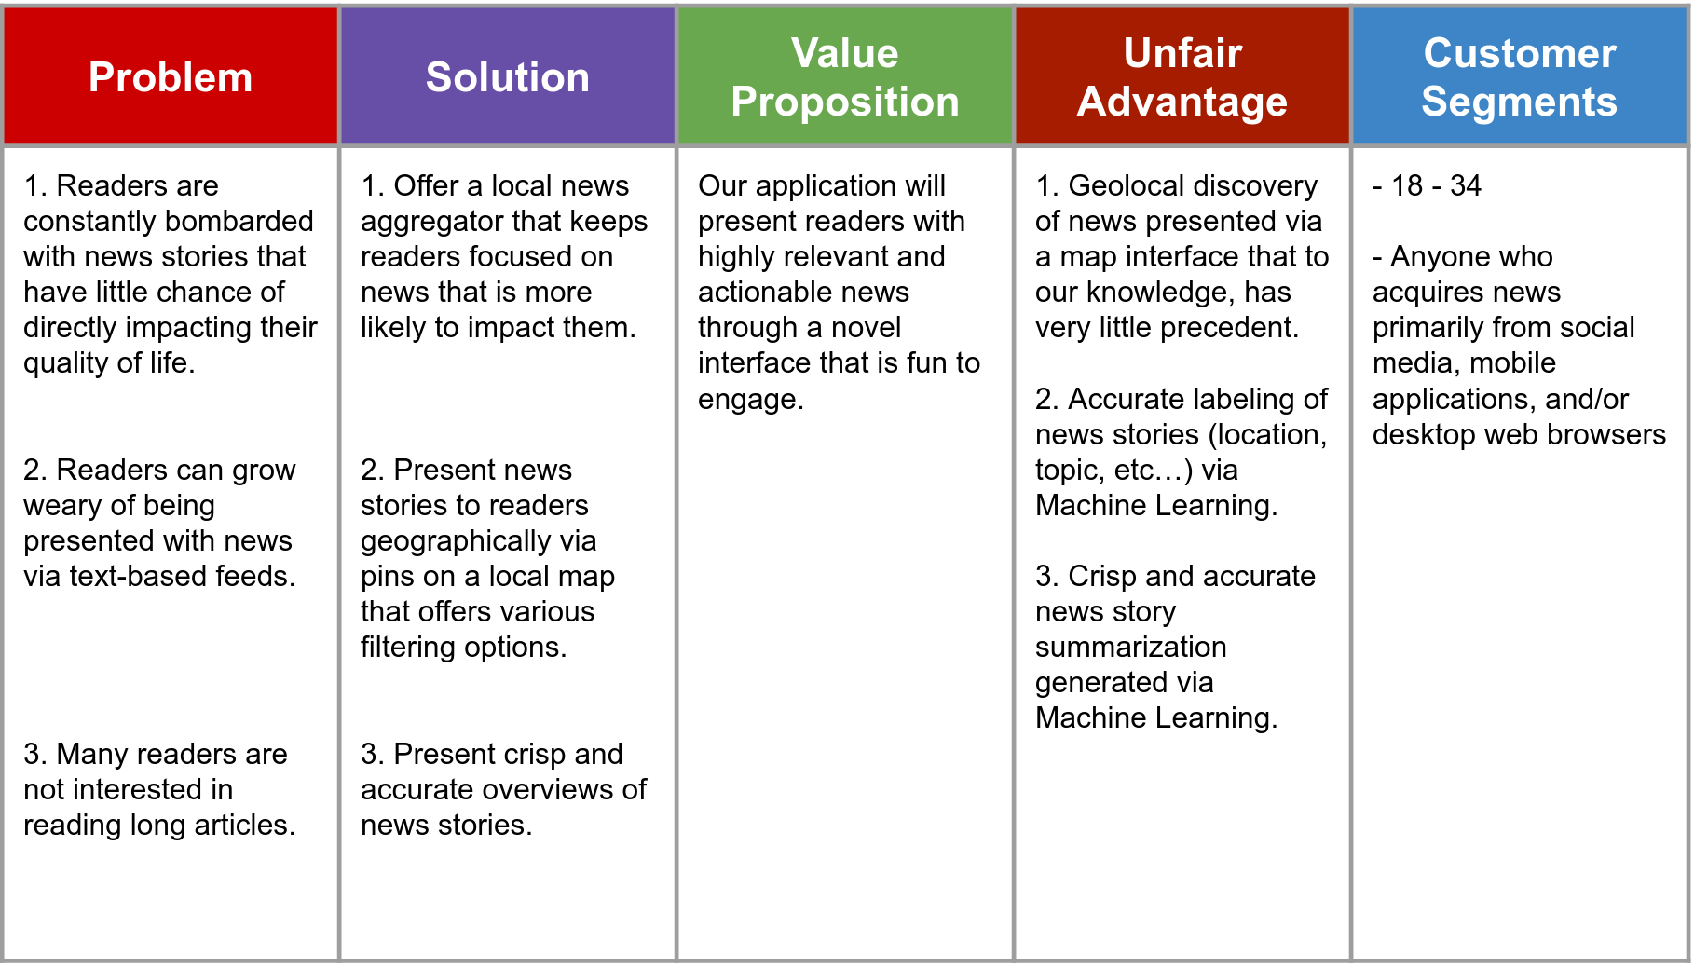

## SWOT

|  |  |
| --- | --- |
| **Strengths** | **Weaknesses** |
| * Two members have previous experience with Machine Learning * There are easily accessible and available resources such as Google's Firebase MLKit that our team can access and use | * Each of us have knowledge and skills in different programming languages and software, which could hinder us since we each will need time to learn new skills * Availability of team members to work on the project due to busy or conflicting class schedules, which could lead to us not making significant progress |
| **Opportunities** | **Threats** |
| * From the experience in Machine Learning as well as available resources, we can create an app with more of the desired features * Using a map interface with pins on locations with news articles as part of the design could help our app to stand out. * Filtering our news using an icon. Plan to implement machine learning model for this * Allow for stories that wouldn’t make major headlines to be viewed | * Our machine learning model could be biased when filtering the articles * There are other local news apps as well as websites that are available * If not constantly updated with news, users may stop using the app * Difficulty to get ML model to summarize the articles properly |

## MARKET SEGMENTS

|  |  |  |  |
| --- | --- | --- | --- |
| **Segment Profile** | | | |
| **Geographic** | **Demographic** | **Behavioral** | **Psychographic** |
| Primarily United States with potential to go worldwide | Younger to middle aged group with a good knowledge of using a phone, and interested in local news | People in this age group is used to social media, and usually bombarded with an enormous amount of information, and a big chunk of it does not have any effects on their life | This age group always has a feeling that they do not have enough time, and they’re always busy. Having a good source news that is customized for them, and can directly affect their life is great help |
| **Size** | | **Growth Potential** | |
| As of 2019, there are around 76 millions millennials in the US | | A lot of adults are interested in the news. An app that can serve them with the news they’re interested in would have a big potential. | |

## PRIMARY MARKET RESEARCH

We decided to create a survey that included questions that may influence our discussions and planning for our project. The survey received 53 responses from mostly computer science students at csulb. Obviously this creates a bias in the survey but it also includes a key demographic that our app could aim for. The survey seems to show a healthy amount of respondents that may be interested in our business. Increasing our pool of respondents may allow us to further understand potential markets that we can target.

|  |
| --- |
| Forms response chart. Question title: On a scale of 1 to 5 how satisfied are you with your method of news consumption?. Number of responses: 54 responses.Forms response chart. Question title: On a scale of 1 to 5 how much do you care about global news?. Number of responses: 54 responses.Forms response chart. Question title: On a scale of 1 to 5 how much do you care about national news?. Number of responses: 54 responses.Forms response chart. Question title: On a scale of 1 to 5 how much do you care about local news?. Number of responses: 54 responses.Forms response chart. Question title: Do you prefer long in-depth news or short summaries of news?. Number of responses: 54 responses.Forms response chart. Question title: What's your preferred method of receiving news: a website or an app?. Number of responses: 54 responses.Forms response chart. Question title: Do you like news notifications on your phone?. Number of responses: 54 responses.Forms response chart. Question title: How often do you search for or read the news?. Number of responses: 54 responses.Forms response chart. Question title: How do you currently receive your news?. Number of responses: 54 responses. |

## SECONDARY MARKET RESEARCH

Before the creation of the internet, people got their news from newspapers and from word-of-mouth. Nowadays, news reaches people through cable news, social media, and news applications online. Due to the advancement of technology, any person is able to get whatever news about any topic in seconds. Millennials, adults ranging from 18-34 years old, have become so accustomed to getting their information through their smartphones, tablets, and laptops. According to research done by the American Press Institute, 69% of millennials get news at least once a day. Many millennials have stated that they get their news from one of the three social media platforms, namely, YouTube, Instagram, and Reddit. In that same study, younger Millennials mentioned that although social media has become a tool they use to gather news, they prefer not to use social media sites, such as Facebook, due to its utility-like qualities. In some ways, this can be interpreted as saying millennials don't like using social media to get accurate real-time news due to its primary purpose of being a relationship networking site, and not a news-reporting platform.

Based on the research done for our upcoming mobile app, Localr's current competitor, InShorts, uses the concept of summarising a news article into 60 words or less so that the users can get more detailed information about an article without having to read the whole article. The company ‘claims that they have introduced artificial intelligence in their app to summarize the content of an article and categorize it to different genres of news. According to the article, the CEO of the company Azhar Iqbual has commented that at the moment, they are able to summarize and publish 10,000 articles 100,000 articles per month. Even though the company uses AI for most of the work, the top read articles on the app which need extreme attention are manually written. Now the company has around 300 over advertisers and around 10 advertisers add on to it approximately every month. They have generated a revenue of around $10 million dollars in 2019 and they expect to double it in the upcoming year. They also plan to expand their customer base to three times their current user base. According to the company, their users are most of the age group of 18-35 years old. Based on our research, they are only our current competitors with the same objective and we believe that there is a huge scope in the news application market especially among the mentioned age group demographic.

With all this being said, there is a market for primarily-news based applications. According to research done by the Pew Research Center, 68% of smartphone users use their phones to access news at least once a day and 88% of the users have at least one news app on their phones. Some social media platforms have implemented certain features in their apps to cater specifically to news reporting. For example, Snapchat's Discover feature has partnered with over 60 entertainment and news channels in order to offer more on-the-go news events to its users.

Additionally, with the emergence of all these possibilities for a user to attain their news, there has also been a call to personalize the news according to people's interests. Based on Aarki's business insights, users seek apps that have personalization. When users get information from an app that is relevant to their lives, they are more likely to use that app more often. Furthermore, users also seek interaction from their news. Aarki states that "Aside from showing different world events, advertising other features, like a gallery of popular shows, movies, or editorials, can make the news app more interactive".

In conclusion, most people get their news from social media due to the ease and accessibility of it. Most millennials use their phones as their primary source for viewing news. People who are interested in apps stay connected due to the relevancy and personalization of the app in regards to their lives. The idea of a localized and summarized news app is already starting to be developed by competitors, however, the accuracy, and the interface of Localr is a concept uncommon to the market, at this time.

Links:

[How InShorts garnered a revenue run rate of $10 million on the back of its advertising model](https://www.businessinsider.in/advertising/brands/article/how-inshorts-became-a-10-million-brand-on-the-back-of-its-advertising-model/articleshow/71425133.cms)

[How Millennials Get News](https://www.americanpressinstitute.org/publications/reports/survey-research/millennials-news/)

[Inshorts debuts AI-based news summarization on its app - ETtech](https://tech.economictimes.indiatimes.com/news/startups/inshorts-debuts-ai-based-news-summarization-on-its-app/64531038)

[Dominating the App Market with Your News App](https://www.aarki.com/blog/dominating-the-app-market-with-your-news-app)

[US Interactive News Map - United States News - usa.liveuamap.com](https://usa.liveuamap.com)

[8 publishers to follow on Snapchat](https://www.cjr.org/business_of_news/snapchat_discover_publishers.php)

## VII. APPENDIX : USER PROFILES

